[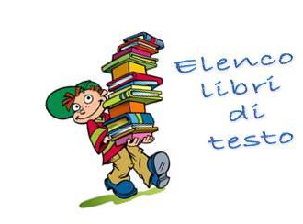](http://www.google.it/url?sa=i&rct=j&q=&esrc=s&source=images&cd=&cad=rja&uact=8&ved=0ahUKEwiM857Az5XNAhWDvBQKHbUADRkQjRwIBw&url=http%3A%2F%2Fwww.istitutocomprensivominturno1.it%2Fweb%2Flibri-di-testo&psig=AFQjCNFepgpXyPvvXQl4pJpB0Sl5vSPdQQ&ust=1465378748154554)

[](http://www.google.it/url?sa=i&rct=j&q=&esrc=s&source=images&cd=&cad=rja&uact=8&ved=&url=http%3A%2F%2Fwww.iclinguaglossacali.gov.it%2FGetContent.aspx%3FID%3D1D4AC46B-5D43-404D-B28D-ABE041418B0D%26TM%3DV%26IM%3D33901446-076d-40db-b8db-8bd39212ebf3&psig=AFQjCNFjyBRmkGCPSSbfKoPVdhskMNrBdg&ust=1465378801453151)